#include<stdio.h>

#include<conio.h>

#include<string.h>

#include<stdlib.h>

#include<dos.h>

#include<time.h>

#include<graphics.h>

main_menu();

instructions();

play();

toss_report();

int main()

{

int a,option;

int gd=DETECT,gm;

initgraph(&gd,&gm,"C:\\TC\\BGI");

main_menu();

printf("Enter option\n");

scanf("%d",&option);

switch(option)

{

case 1:

cleardevice();

play();

break;

case 2:

cleardevice();

instructions();

cleardevice();

main();

break;

case 3:

exit(0);

break;

default:

printf("Wrong Input");

}

getch();

return 0;

}

main_menu()

{

outtextxy(220,100,"NSTPro's Book Cricket");

rectangle(250,150,360,180); //PLAY button

setfillstyle(9,4);

floodfill(251,151,WHITE);

outtextxy(285,160,"PLAY");

rectangle(250,220,360,250); //INSTRUCTIONS button

setfillstyle(9,2);

floodfill(251,221,WHITE);

outtextxy(260,230,"INSTRUCTIONS");

rectangle(250,290,360,320); //EXIT button

setfillstyle(9,1);

floodfill(251,291,WHITE);

outtextxy(290,300,"EXIT");

outtextxy(270,350,"MAIN MENU");

setcolor(YELLOW);

outtextxy(220,400,"Press Enter to continue");

setcolor(WHITE);

getch();

return 0;

}

instructions()

{

printf("INSTRUCTIONS/RULES\n");

printf("\n1) Press Enter key to play each ball\n");

printf("2) Mode of runs: 1,2,3,4,5,6\n");b

printf("3) 0 run is equal to one wicket\n");

printf("4) 1 over, 2 overs, 3 overs match\n");

printf("5) The team which scores more runs is the winner\n");

printf("6) The match results in a tie if both the teams score equal runs\n");

printf("7) Use '_'instead of spacebar to type team/captain/venue name.\n");

setcolor(YELLOW);

outtextxy(150,400,"Press Enter to go back to Main Menu");

setcolor(WHITE);

getch();

return 0;

}

play()

{

int over1=1, over2=1, test=0;

int check=0;

int m,n,a,p; char team1[30],team2[30],capt1[50],capt2[50],venue[30],b[100];

int num1,num2,i,j,k,l,run1=0,wicket1=0,run2=0,wicket2=0;

printf("Enter your team name\n");

scanf("%s",team1);

printf("Enter your team captain name\n");

scanf("%s",capt1);

printf("\nEnter your opponent team name\n");

scanf("%s",team2);

printf("Enter opponent team captain name\n");

scanf("%s",capt2);

printf("\nEnter venue\n");

scanf("%s",venue);

printf("\nChoose over\n1 over\n2 overs\n3 overs\n\n");

scanf("%d",&a);

if(a<1||a>3)

{

printf("Wrong input for overs\n");

}

else

{

printf("\n%s vs %s",team1,team2);

printf("\n%s Stadium",venue);

printf("\n%d over match\nDECIDED!",a);

printf("\n\nPress Enter to continue");

}

getch();

cleardevice();

setcolor(YELLOW);

outtextxy(250,20,"TOSS REPORT");

setcolor(12);

sprintf(b,"Hello and warm welcome, this is NSTPro present at the %s Stadium for the",venue);

outtextxy(0,60,b);

sprintf(b,"%d over exhibition match between %s and %s.",a,team1,team2);

outtextxy(0,80,b);

sprintf(b,"We have %s captain, %s and %s captain, %s alongside us.",team1,capt1,team2,capt2);

outtextxy(0,100,b);

outtextxy(0,120,"It's the toss time between the two sides!");

setcolor(WHITE);

outtextxy(0,150,"1.Heads");

outtextxy(0,160,"2.Tails");

outtextxy(0,190,"Make your call!");

scanf("%d",&m);

if(m==1)

{

setcolor(12);

sprintf(b,"Heads is the call and it is Heads! So it's %s who have won the toss!",team1);

outtextxy(0,220,b);

setcolor(WHITE);

outtextxy(0,250,"Choose option");

outtextxy(0,270,"1.Bat");

outtextxy(0,280,"2.Bowl");

}

if(m==2)

{

setcolor(12);

sprintf(b,"Tails is the call and it is Tails! So it's %s who have won the toss!",team1);

outtextxy(0,220,b);

setcolor(WHITE);

outtextxy(0,250,"Choose option");

outtextxy(0,270,"1.Bat");

outtextxy(0,280,"2.Bowl");

}

scanf("%d",&p);

cleardevice();

setcolor(YELLOW);

outtextxy(250,20,"TOSS REPORT");

setcolor(WHITE);

if(p==1)

{

setcolor(12);

sprintf(b,"%s: Looks like a good pitch to bat on. The ball will come nicely on the bat.",capt1);

outtextxy(0,50,b);

sprintf(b,"Also it's a quick outfield here at the %s ground, so we will be looking to",venue);

outtextxy(0,70,b);

outtextxy(0,90,"set up a good target for them and hopefully defend it.");

setcolor(WHITE);

sprintf(b,"NSTPro: Thanks %s, good luck! Now we have %s captain, %s.",capt1,team2,capt2);

outtextxy(0,120,b);

setcolor(12);

sprintf(b,"%s: Well we would have bat first as well but the toss is not in our",capt2);

outtextxy(0,150,b);

outtextxy(0,170,"hands. We will be looking to restrict them to as low score as possible.");

outtextxy(0,190,"We have a good top order and so will chase the score with positive mindset.");

setcolor(WHITE);

sprintf(b,"NSTPro: Thank you %s. So here's the news from the centre, it's %s",capt2,team1);

outtextxy(0,220,b);

outtextxy(0,240,"who have won the toss and have elected to bat first.");

check++;

}

if(p==2)

{

setcolor(12);

sprintf(b,"%s: Quite overcast conditions today. The ball will swing a lot in the initial",capt1);

outtextxy(0,50,b);

sprintf(b,"overs. %s is known for swinging the ball. The dew factor will play a huge",venue);

outtextxy(0,70,b);

outtextxy(0,90,"role later in the 2nd Innings. So we will restrict them to low score and chase it.");

setcolor(WHITE);

sprintf(b,"NSTPro: Thanks %s. Now we have %s captain, %s.",capt1,team2,capt2);

outtextxy(0,120,b);

setcolor(12);

sprintf(b,"%s: We were looking to bat first anyways. The sun is not out there today.",capt2);

outtextxy(0,150,b);

outtextxy(0,170,"We are playing an extra batsman today. It's necessary to keep the scoreboard");

outtextxy(0,190,"ticking. Will try to post a good target in front of them today. I think the");

outtextxy(0,210,"spinners will get help in the 2nd Innings, so we are happy to bat first.");

setcolor(WHITE);

sprintf(b,"NSTPro: Thank you %s. So here's the news from the centre, it's %s",capt2,team1);

outtextxy(0,240,b);

outtextxy(0,260,"who have won the toss and have elected to bowl first.");

}

getch();

cleardevice();

clrscr();

setfillstyle(1,BLACK);

floodfill(10,10,WHITE);

if(a==1)

{

n=6;

}

if(a==2)

{

n=12;

}

if(a==3)

{

n=18;

}

for(j=0;j<n;j++)

{

clrscr();

setfillstyle(1,BLACK);

floodfill(10,10,WHITE);

rectangle(460,20,600,45); //STAR SPORTS channel

setfillstyle(1,RED);

floodfill(461,21,WHITE);

setcolor(WHITE);

outtextxy(480,30,"STAR SPORTS");

outtextxy(520,50,"LIVE");

setcolor(WHITE);

randomize();

for(i=1;i<=1;i++)

{

num1=(rand()% (6 - 0+1)+0);

if(num1==0)

{

wicket1++;

}

else

{

run1+=num1;

}

if(p==1)

{

printf("\n\nScore: 1st Innings\n\n %s: %d/%d\t %s won the toss\n",team1,run1,wicket1,team1);

}

if(p==2)

{

printf("\n\nScore: 1st Innings\n\n %s: %d/%d\t %s won the toss\n",team2,run1,wicket1,team1);

}

if(wicket1==10)

{

printf("Game Over! \n You Lose.\n");

return 0;

}

}

printf("\ Overs: %d.%d\t\t LIVE from %s\n",test,over1,venue);

over1++;

if(over1==6)

{

over1=0;

test++;

}

rectangle(0,60,400,100); //scorecard

if(num1==0)

{

setcolor(YELLOW);

outtextxy(0,120,"Bowled'em! Knocks him over.");

}

else if(num1==1)

{

setcolor(YELLOW);

outtextxy(0,120,"Taps it towards mid-off for a single.");

}

else if(num1==2)

{

setcolor(YELLOW);

outtextxy(0,120,"Good shot. Plays it through extra covers for two runs.");

}

else if(num1==2)

{

setcolor(YELLOW);

outtextxy(0,120,"That's a very good shot. It's a slow outfield and the ball");

outtextxy(0,130,"just stops before reaching the boundary. 3 runs taken");

}

else if(num1==4)

{

setcolor(YELLOW);

outtextxy(0,120,"Hooks it away! One bounce over the rope for a boundary.");

}

else if(num1==5)

{

setcolor(YELLOW);

outtextxy(0,120,"Oh this is very unfortunate! The ball hits the wicketkeeper's");

outtextxy(0,130,"helmet. 5 bonus runs for the batting side.");

}

else if(num1==6)

{

setcolor(YELLOW);

outtextxy(0,120,"Slogs it over mid-on for a huge six!");

}

setcolor(WHITE);

getch();

printf("\n\n\n\nPress Enter to play the next ball");

getch();

}

if(p==1)

{

printf("\n\n Total\n %s: %d/%d",team1,run1,wicket1);

printf("\n %s need %d runs to win from %d over",team2,run1+1,a);

}

if(p==2)

{

printf("\n\n Total\n %s: %d/%d",team2,run1,wicket1);

printf("\n %s need %d runs to win from %d over",team1,run1+1,a);

}

getch();

cleardevice();

clrscr();

setfillstyle(1,BLACK);

floodfill(10,10,WHITE);

if(a==1)

{

n=6;

}

if(a==2)

{

n=12;

}

if(a==3)

{

n=18;

}

test=0;

for(k=0;k<n;k++)

{

clrscr();

setfillstyle(1,BLACK);

floodfill(10,10,WHITE);

rectangle(460,20,600,45); //STAR SPORTS channel

setfillstyle(1,RED);

floodfill(461,21,WHITE);

setcolor(WHITE);

outtextxy(480,30,"STAR SPORTS");

outtextxy(520,50,"LIVE");

setcolor(WHITE);

randomize();

for(l=1;l<=1;l++)

{

num2=(rand()%(6-0+1)+0);

if(num2==0)

{

wicket2++;

}

else

{

run2+=num2;

}

if(wicket2==10)

{

printf("You Lose!");

getch();

return 0;

}

if(p==1)

{

printf("\n\nScore: 2nd Innings\n\n %s: %d/%d\t %s won the toss\n",team2,run2,wicket2,team1);

}

if(p==2)

{

printf("\n\nScore: 2nd Innings\n\n %s: %d/%d\t %s won the toss\n",team1,run2,wicket2,team1);

}

if(check==1)

{

}

}

printf("\ Overs: %d.%d\t\t LIVE from %s\n",test,over2,venue);

over2++;

if(over2==6)

{

over2=0;

test++;

}

rectangle(0,60,400,100); //scorecard

if(num2==0)

{

setcolor(YELLOW);

outtextxy(0,120,"In the air and gone! What a brilliant catch by the fielder!");

}

else if(num2==1)

{

setcolor(YELLOW);

outtextxy(0,120,"Driven away towards the cover regions for a single.");

}

else if(num2==2)

{

setcolor(YELLOW);

outtextxy(0,120,"Nicely flicked! Should get a couple of runs easily.");

}

else if(num2==2)

{

setcolor(YELLOW);

outtextxy(0,120,"Oh that's smashed away! The fielder just dives to save a boundary.");

outtextxy(0,130,"The batsmen come back for 3.");

}

else if(num2==4)

{

setcolor(YELLOW);

outtextxy(0,120,"Magnificent shot! Cuts it over point for a four. The chase is on fire!");

}

else if(num2==5)

{

setcolor(YELLOW);

outtextxy(0,120,"Oh my goodness! Poor fielding. Overthrow and four extra runs.");

}

else if(num2==6)

{

setcolor(YELLOW);

outtextxy(0,120,"That's a glorious hit down the ground for a maximum!");

}

setcolor(WHITE);

printf("\n\n\n\nPress Enter to play the next ball");

getch();

}

if (run2>run1)

{

if(p==1)

{

printf("\n\n%s won the match by %d wickets",team2,10-wicket2);

}

if(p==2)

{

printf("\n\n%s won the match by %d wickets",team1,10-wicket2);

}

}

else if(run1>run2)

{

if(p==1)

{

printf("\n\n\n%s won the match by %d runs",team1,run1-run2);

}

if(p==2)

{

printf("\n\n\n%s won the match by %d runs",team2,run1-run2);

}

}

else

{

printf("\n\nMatch tied!");

}

setcolor(RED);

outtextxy(150,330,"Thank you for playing NSTPro's Book Cricket!");

setcolor(YELLOW);

outtextxy(250,350,"Press Enter to play again");

setcolor(WHITE);

getch();

cleardevice();

main();

return 0;

}

**OUTPUTS:**

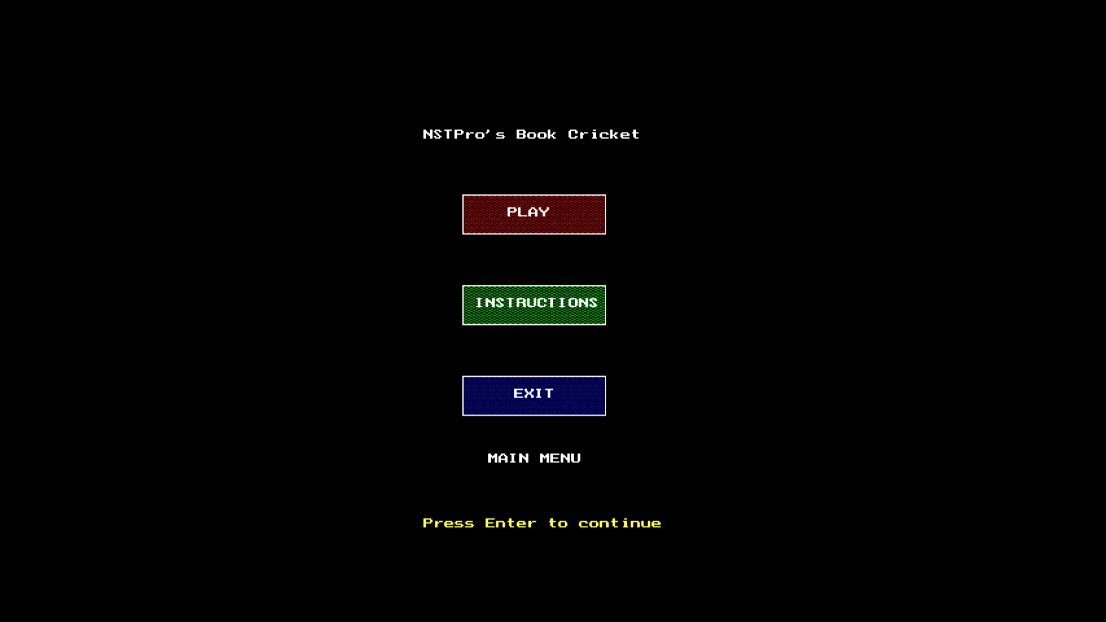

**MAIN MENU**

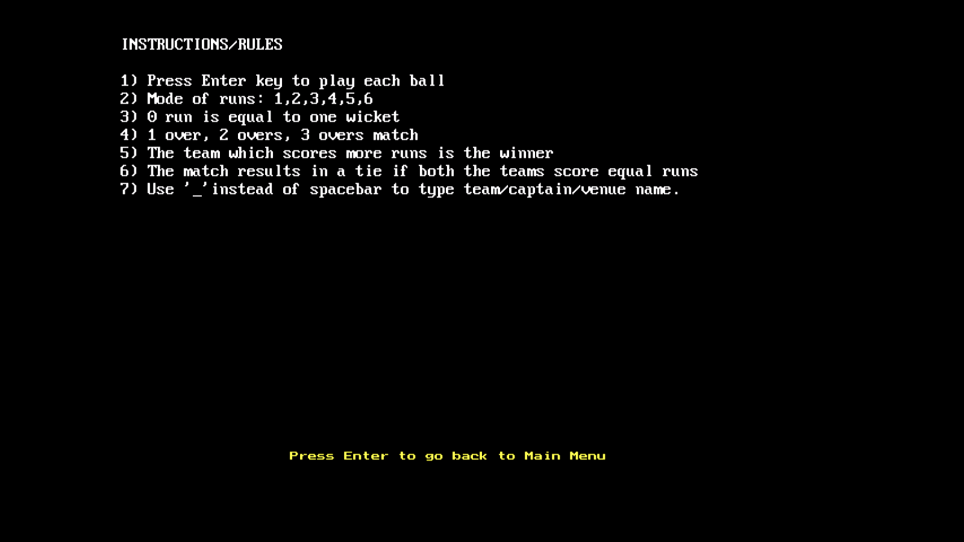

**GAME INSTRUCTIONS/RULES**

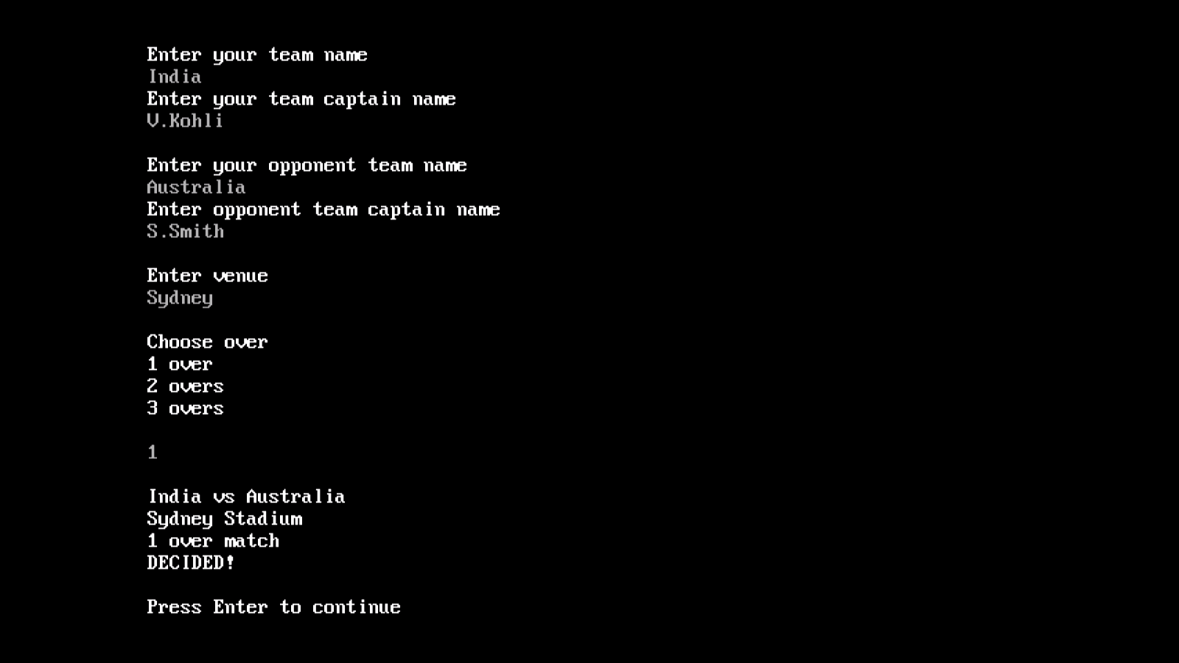

**GAME MATCH SETTINGS**

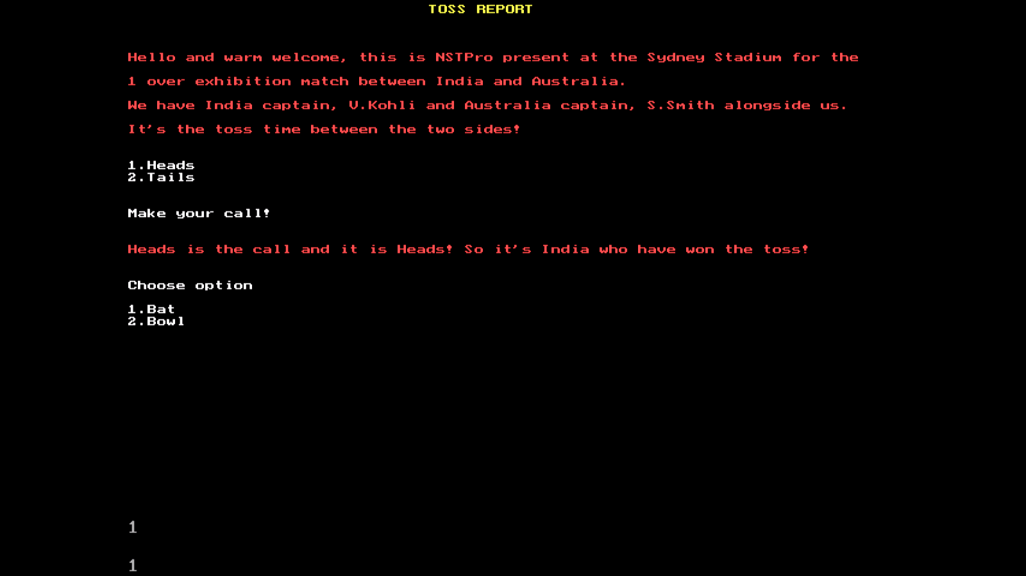

**TOSS REPORT**

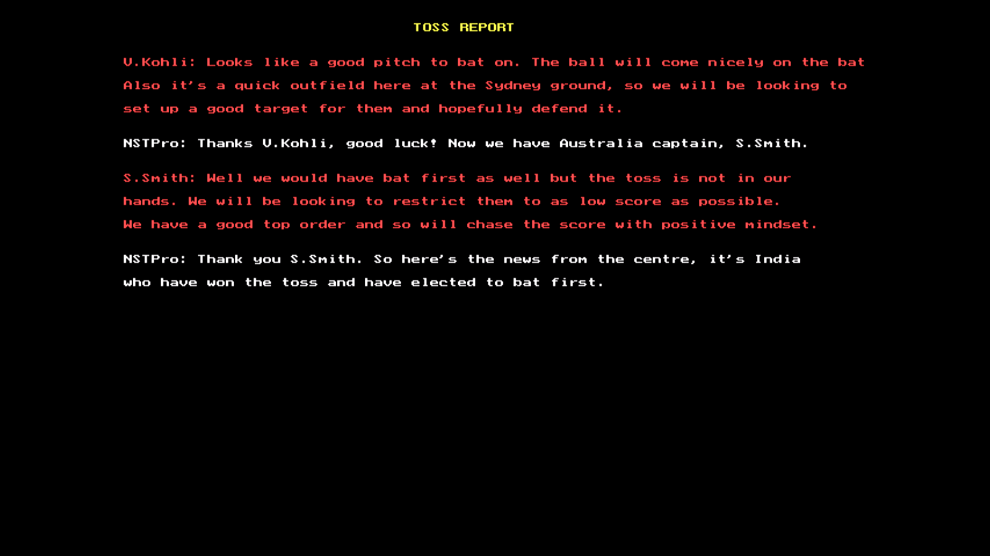

**TOSS INTERVEIW**

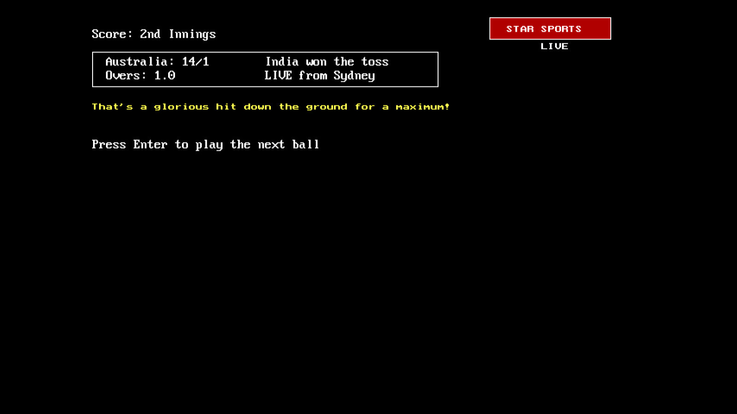

**SCORECARD**